
Company
Logotype

Cone Beam Computed Tomography- Report



Porur Dental X-rays & CBCT

Patient Name : Mr. Ramesh | Date of Report : 13.03.2024
Age/ Gender : 50 years/ Male | Region of Interest : CBCT Full Skull
Referring doctor: Dr. Suchitra Mohan | Indication : Temporal region pain in- right side
Clinical Notes: Nil
PATIENT INFORMATION

CBCT- Full skull provided
CBCT – IMAGE DETAILS

RADIOGRAPHIC INTERPRETATION

- Missing teeth : 37.
- Impacted teeth: 18, 28, 38; Partially erupted: 48
- Root Stumps: 47; Distance between the Inferior alveolar nerve canal and the apical portion of root stumps is 9.4 mm
During rest position – Right Temporomandibular joint:
- In relation to the right temporomandibular joint, presence of mild degenerative changes in the superior surface of the head of the condyle evident.
- The temporal bone in the right side is present with normal morphology.
- The nasal passage in the right side appears narrow and constricted.

RADIOGRAPHIC IMPRESSION

- Root stumps: 47.
- Impacted teeth: 18, 28, 38; Partially erupted: 48
- Mild Internal derangement of Temporomandibular joint – Right side.

Kindly correlate with clinical findings


IMAGES FOR REFERENCE

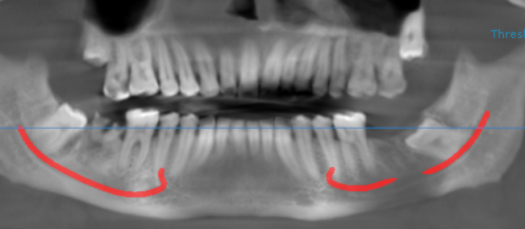

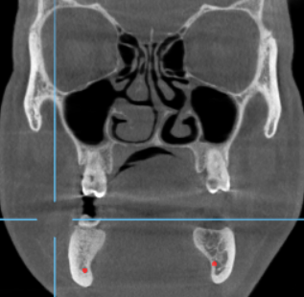
Narrow nasal passage

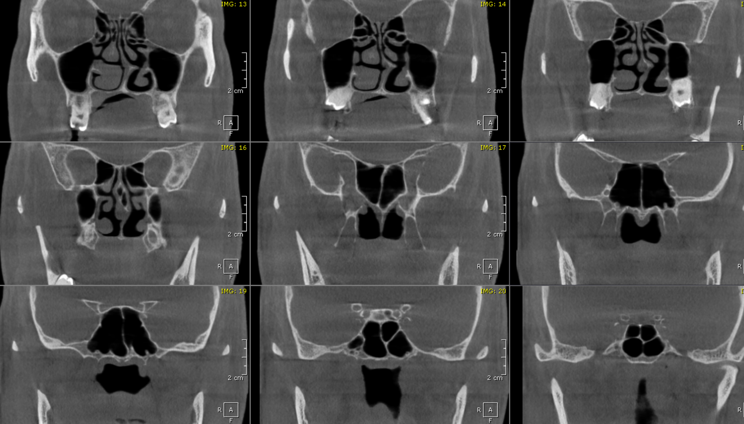
CORONAL VIEW

3 DIMENSIONAL VIEW
Right Side
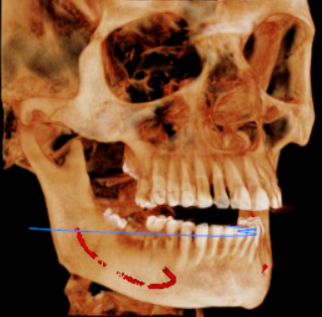

**** End of report ****

